Name | Intersection matrix | mask code string | Meaning and definition | Equivalent
Disjoint | $$\left[\begin{matrix}F & F & * \\ F & F & * \\ * & * & *\end{matrix}\right]$$ | FF*FF**** | a and b have no points in common. | not Intersects
Borders | $$\left[\begin{matrix}F & F & * \\ F & 1 & * \\ * & * & *\end{matrix}\right]$$ | FF*F1**** | The boundaries of a and b have more than one point in common, but their interiors do not intersect.
Overlaps | $$\left[\begin{matrix}2 & * & 2 \\ * & * & * \\ 2 & * & *\end{matrix}\right]$$ | 2*2***2** | a overlaps b: they have some but not all points in common.
Equals | $$\left[\begin{matrix}2 & * & F \\ * & * & F \\ F & F & *\end{matrix}\right]$$ | 2*F**FFF* | The interiors of a and b intersect and no part of the interior or boundary of one geometry intersects the exterior of the other. | Within & Contains
Delimits | $$\left[\begin{matrix}2 & * & F \\ * & 1 & F \\ * & * & *\end{matrix}\right]$$ | 2*F*1F*** | The boundaries of a and b have more than one point in common, and a lies in the interior of b. | Encompasses(b,a)
Encompasses | $$\left[\begin{matrix}2 & * & * \\ * & 1 & * \\ F & F & *\end{matrix}\right]$$ | 2***1*FF* | The boundaries of a and b have more than one point in common, and b lies in the interior of a. | Delimits(b,a)
Within | $$\left[\begin{matrix}2 & * & F \\ * & * & F \\ * & * & *\end{matrix}\right]$$ | 2*F**F*** | >a lies in the interior of b. | Contains(b,a)
Contains | $$\left[\begin{matrix}2 & * & * \\ * & * & * \\ F & F & *\end{matrix}\right]$$ | 2*****FF* | No points of b lies in the exterior of a, and some of the points of the interior of b lie in the interior of a. | Within(b,a)
Surrounds |  |  | a and b have no interior points in common, and with holes filled b lies in the interior of a.
Embeds |  |  | a and b have no interior points in common, and with holes filled a lies in the interior of b.

Notes:
- The order of the definitions matters, for example a Delimits b is a special case of a Within b, where a and b share a border.
- The definition of Borders used here only applies to external borders.
a Surrounds b takes precedent over a Borders b.
- For most relationship masks, the relations between a and b with the holes filled is trivial and ignored.

Object with hole.
Borders | Surrounds | Overlaps | ?

Surrounds is the only relation not already captured.

### Objects with holes
There is one additional relationship to be captured:

![Surrounds](attachment:image.png)

**Surrounds**

When the exterior of shape $a$ completely *covers* shape $b$, but does not
*contain* it, then shape $a$ *surrounds* $b$.

This will be identified by adding a second *DE-9IM* sequence describing the
relationship between shape $a$ and shape $b$ after filling all holes in
both shapes. If this sequence matches a _contains_ relation then
$a$ *surrounds* $b$. If this sequence matches a _within_ relation then
$a$ *embeds* $b$.

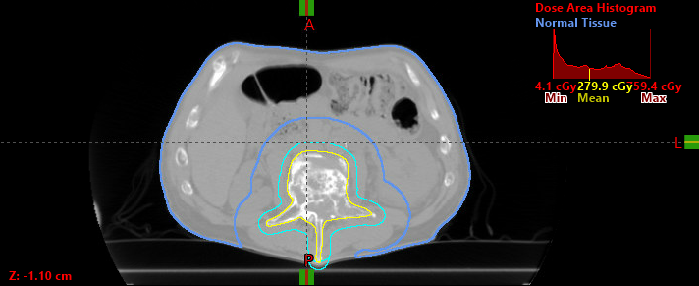

Normal tissue does not surround PTV, but Margin still of interest

- Need to be able to select specific metrics
- Need a generic set of relations that don't meet normal criteria

def relation_names(relation_string: str)->str:
'''Match relationship strings with named relationships

The defined relationships are:
- Disjoint: a and b have no points in common, and with holes removed a and b
still have no points in common.
- Borders: The boundaries of a and b have more than one point in common,
but their interiors do not intersect.
- Overlaps: a and b have some but not all points in common.
- Equals: The interiors of a and b intersect and no part of the interior or
boundary of one geometry intersects the exterior of the other.
- Delimits: The boundaries of a and b have more than one point in common,
and a lies in the interior of b.
- Encompasses: The boundaries of a and b have more than one point in common,
and b lies in the interior of a.
- Within: a lies in the interior of b.
- Contains: No points of b lies in the exterior of a, and some of the the
points of the interior of b lie in the interior of a.
- Surrounds: a and b have no interior points in common, and with holes
filled b lies in the interior of a.
- Embeds: a and b have no interior points in common, and with holes
filled a lies in the interior of b.

Notes: The order of the definitions for the masks matters, for example:
a 'Delimits' b is a special case of a 'Within' b, where a and b
share a border. The definition of 'Borders' used here only applies to
external borders' a 'Surrounds' b takes precedent over a 'Borders' b.
For most relationship masks, the relations between a and b with the
holes filled is trivial and ignored.

Args:
relation_string (str): A 9 character relationship string following the
DE-9IM pattern. Each character can be one of the following:
F, 0, 1, 2

Returns:
str: The name of the matched relationship or an empty string if no
match was found.
'''
relation_masks = {
'Disjoint': re.compile(r'FF.FF....' + 'F........'),
'Overlaps': re.compile(r'2.2...2..'),
'Delimits': re.compile(r'2.F.1F...'),
'Encompasses': re.compile(r'2...1.FF.'),
'Contains': re.compile(r'2.....FF.'),
'Within': re.compile(r'2.F..F...'),
'Equals': re.compile(r'2.F..FFF.'),
'Embeds': re.compile(r'FF.F.....' + '2.F......'),
'Surrounds': re.compile(r'FF.F.....' + '2.....F..'),
'Borders': re.compile(r'FF.F1....'),
}
for relation, pattern in relation_masks.items():
match = pattern.match(relation_string)
if match:
return relation
return ''

